Xml

<LinearLayout xmlns:android="http://schemas.android.com/apk/res/android"  
 android:layout_width="match_parent"  
 android:layout_height="match_parent"  
 android:orientation="vertical"  
 android:gravity="center">  
  
 <ImageView  
 android:id="@+id/imageView"  
 android:layout_width="200dp"  
 android:layout_height="200dp"  
 android:src="@drawable/ic_launcher_background"/>  
  
 <Button  
 android:id="@+id/playButton"  
 android:layout_width="wrap_content"  
 android:layout_height="wrap_content"  
 android:text="Play Audio"/>  
  
 <Button  
 android:id="@+id/stopButton"  
 android:layout_width="wrap_content"  
 android:layout_height="wrap_content"  
 android:text="Stop Audio"/>  
</LinearLayout>

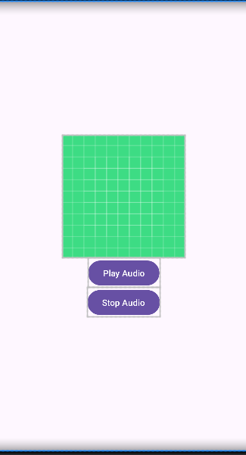

Mainactivity.kt

import android.media.MediaPlayer  
import android.os.Bundle  
import android.widget.Button  
import android.widget.ImageView  
import androidx.appcompat.app.AppCompatActivity  
  
class MainActivity : AppCompatActivity() {  
 private lateinit var mediaPlayer: MediaPlayer  
  
 override fun onCreate(savedInstanceState: Bundle?) {  
 super.onCreate(savedInstanceState)  
 setContentView(R.layout.*activity_main*)  
  
 val playButton: Button = findViewById(R.id.*playButton*)  
 val stopButton: Button = findViewById(R.id.*stopButton*)  
 val imageView: ImageView = findViewById(R.id.*imageView*)  
  
 // Set an image to ImageView  
 imageView.setImageResource(R.drawable.*ic_launcher_background*)  
  
 // Initialize MediaPlayer with an audio file from res/raw  
 mediaPlayer = MediaPlayer.create(this, R.raw.songs)  
  
 playButton.setOnClickListener **{** if (!mediaPlayer.*isPlaying*) {  
 mediaPlayer.start()  
 }  
 **}** stopButton.setOnClickListener **{** if (mediaPlayer.*isPlaying*) {  
 mediaPlayer.pause()  
 mediaPlayer.seekTo(0)  
 }  
 **}** }  
  
 override fun onDestroy() {  
 super.onDestroy()  
 mediaPlayer.release()  
 }  
}